Rotary Club of Kathmandu Mid-Town
Breakfast Chatter




23 March 2012 The Weekly Bulletin of Rotary Club of Kathmandu Mid-Town Bc-3.23/011-12

District: 3292 Web: www.rotarymidtown.org.np Club Id : 26776

MARCH IS LITERACY MONTH
Teach children the value of life, and that they should respect others, no matter what sex or caste they belong to. If you can change their way of thinking, and introduce them to a better way of life,
you will be doing them and the entire community a great service.

16 March, Friday
Dr Niti Rana was our Guest speaker who provided an interesting talk on the phenomenon of school bullying.
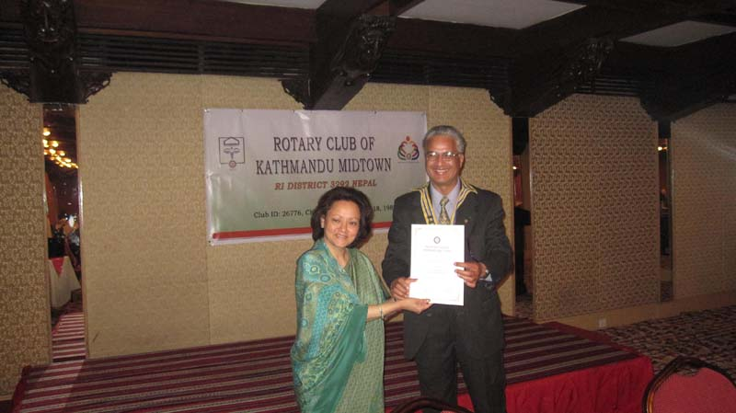
President Som handing over certificate of appreciation to Dr Niti Rana
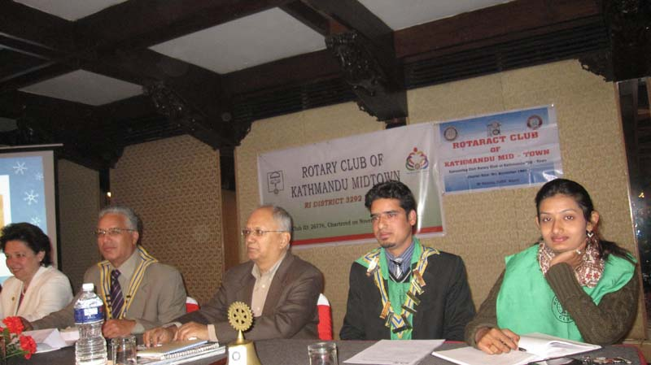
Joint meeting with Rotaract Club of Kathmandu Mid-Town on 9 March;
Rtr President Samir providing club activities report.

Weekly Meetings and Programs :
Date | Program/Speaker | Program/Topics of Presentation
23 March 2012 | Fionna Heiton | Play-based learning and child friendly teaching in schools
30 March 2012 | Archana Thapa | Alternative History: Women's Personal Stories
6 April 2012 | CP Roop Jyoti | Why Vipassana Meditation?

Past President Meeting :
Past Presidents of Rotary Club of Kathmandu Mid-Town met in a dinner meeting on 19 March 2012 at Tukuche Kitchen, Lazimpat, to discuss and decide on some important issues. The meeting was hosted by Charter President Roop.
PP Komal, although he has to undergo another operation this week, attended this important meeting, and he was greeted warmly by all.
DGE Yogendra Pradhan informed two important events DTTS at Butwal and PETS at Pokhara were organized and conducted very successfully.
He also informed on two other important events: DG installation and RI President-Elect Rtn Sakuji Tanaka’s visiting Nepal on 18-21 Nov 2012 and he has constituted a committee to prepare for his visit.
The important agenda was whether Rotary Club of Kathmandu Mid-Town should contest for DG for the year 2015-16. It was agreed that we should contest, and interested PP should send in his or her candidature either by oneself or nominated by another PP to CP Roop by 17:00 hrs 26 March 2012 (Monday).
PP Anand, Chair District Conference 2013, requested cooperation from all PPs for organizing and making the Conference a grand success.

Rtn Lisa, Chair, Membership Committee, announced the result of membership satisfaction survey which the committee conducted last month. The survey result (charts) has been distributed to all, therefore, not annexed herewith.

John Hewko outlines five priorities for strengthening Rotary’s image:
Rotary Club Central
The third priority, developing a new tool called Rotary Club Central, will help Rotary place a value on the thousands of service projects clubs do each year. The online resource will help clubs maintain a record of past activities; set and track strategic goals and initiatives; and allow reporting of the global, collective impact of club, district, and zone activities.
“We know how much funding passes through The Rotary Foundation -- approximately $100 million per year excluding polio [funding] -- but we have no idea of the total value of all of the money raised, in-kind contributions made, and volunteer hours spent by clubs worldwide on service projects,” Hewko said. “Having a credible number would enhance our reputation, help with membership, and make us more attractive to potential strategic partners.”
Membership
The fourth priority is membership, including making Rotary more appealing and relevant to younger members. The RI Board has launched an initiative to develop three-year regional membership plans tailored to specific regional needs and challenges. Achieving this priority will also require revamping the website to improve performance and make it more user friendly, increasing use of social media, looking at expanding e-clubs, and giving clubs greater flexibility with attendance requirements.
The board is also working with an international agency with a track record of success to provide a fresh global perspective of Rotary’s brand, its membership, core strengths, competition, and operating philosophy.
“Ultimately, I believe, this process will more than revitalize a brand. It will revitalize Rotary -- ensuring that Rotary is recognized the world over for what it does,” Hewko said. “And make no mistake: what Rotary does is nothing short of amazing.”
Humanitarian assistance
The fifth priority is positioning Rotary more fully as a major player in global humanitarian assistance and development.
“Here we have Rotary, with its incredible platform of 1.2 million engaged, active, and motivated members, drawn from the business and professional networks of tens of thousands of communities,” Hewko said. “In short, a private-sector platform that is unmatched in the world today.”
“I re-pledge to you today that I will invest every ounce of my energy to ensure that the Rotary flame burns ever brighter, so that working together we can continue to make the world a better place,” he said. “For our families and friends, for our communities and countries, and for future generations to come.“
Source: Arnold R. Grahl/Rotary International News

And since development leads to prosperity and prosperity leads to peace, let’s continue to build
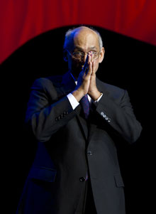
communities. It may be by doing something huge, like building a dam or a bridge over rivers. Or it may be
something small, like putting desks or fans or blackboards in classrooms in a school. As you go ahead,
you will find that what really matters is just your willingness to meet the need, and not the size of the
project.
RI President Kalyan Banerjee

On Lighter Side : Click here ⇩


A thought for the day:
Life is a tragedy when seen in close-up,
but a comedy in long-shot.
- Charlie Chaplin

Buford City, USA; Population : 1

Buford, Wyoming: What’s advertised as the smallest town in the United States is scheduled to go up for auction next month. Buford, located between Cheyenne and Laramie in southeast Wyoming, is famous for having just one inhabitant, Don Sammons. Sammons plans to retire from managing his businesses at Buford and move on. The auction is set for noon on April 5. Buford traces its origins the 1860s and the construction of the Trans-continental Railroad and had as many as 2,000 residents before the railroad was re-routed. Sammons and his family moved from Los Angeles to Buford in 1980. Family members moved away over the years, but Sammons stayed on as sole resident and “mayor” of the unincorporated community.
Source: The Rising Nepal

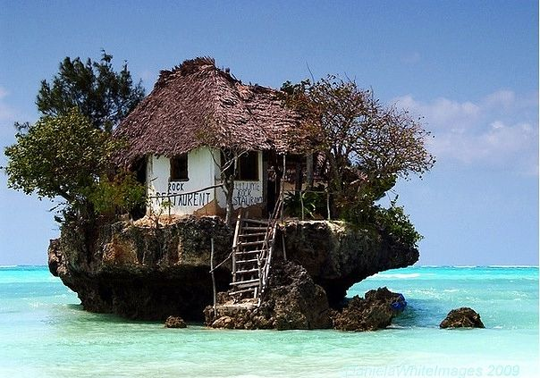
Cliff restaurant Zanzibar and Isle of Lamu

Please send project/activity information, suggestions and photos etc to :
BC Editor: RR Shrestha email: rryes@wlink.com.np

23 March 2012 The Weekly Bulletin of Rotary Club of Kathmandu Mid-Town bc-3.23/011-12

